AgroSense - A Remote Monitoring Greenhouse Agricultural Farming with Edge Computing System
1 Harshitha BN, 2 Ragavendra K, 3 Sudharshan D, 4 Sudharshan MS, 5 Supriya V, Department of Artificial Intelligence and Data Science, S J C Institute of Technology, Chikkaballapur, India, Email: b.naidu.harshitha@gmail.com, kraghavendra214@gmail.com, sudharshand67@gmail.com, sudhums613@gmail.com, supriya04v@gmail.com
ABSTRACT: In order to guarantee year-round food production, greenhouse farming is becoming more and more popular. However, many monitoring systems currently in use rely mostly on manual inspection or erratic cloud connectivity, which leads to inefficiencies and delayed reactions. AgroSense is a greenhouse monitoring system powered by edge computing that uses a network of sensors and a Raspberry Pi to autonomously control environmental conditions. Important variables like soil moisture, pH levels, humidity, temperature, gas concentration, intensity of light and animals infiltration are all monitored by the system. Real-time edge-based decision-making powers automated systems including gas warnings, lighting controls, irrigation control, and intrusion alarms. During dangerous situations, GSM notifications improve system responsiveness. AgroSense guarantees dependability in remote and poorly connected areas by removing reliance on the cloud. The technology promotes sustainable smart agriculture, lessens manual work, and improves crop protection.
KEY WORDS: Smart agriculture, Edge computing, Raspberry Pi, Automation, IoT sensors, Green- house monitoring, GSM alerts.
1. INTRODUCTION:
Because greenhouse agriculture offers a steady and regulated environment for crop cultivation, it is essential to modern food production. However, because traditional greenhouse monitoring primarily relies on human inspection, decision-making is delayed, environmental conditions are inaccurately assessed, and resources are used inefficiently. Automation, precision monitoring, and real-time control over agriculture have been made possible by the emergence of smart farming technologies including edge computing, embedded systems, and the Internet of Things.
AgroSense is a Raspberry Pi-based edge-based monitoring and automation solution. For measuring moisture in the soil, level of pH, humidity, temperature, intensity of light, gas concentration, and animal presence, the system incorporates a number of sensors. Maintaining ideal greenhouse conditions depends on these factors. While a GSM module sends out real-time notifications in the event of anomalous situations, AgroSense utilises relays, pumps, and lighting systems to automatically control the environmental changes. The solution guarantees continuous functioning even in isolated agricultural areas with poor connectivity by minimizing reliance on the cloud.

2. LITERATURE REVIEW:
The increasing significance of embedded systems and Internet of Things (IoT) technology in greenhouse monitoring systems has been highlighted by recent developments in agricultural automation. Research by Manoj et al. (2023) demonstrates the feasibility of utilizing Raspberry Pi–based platforms for continuous environmental sensing in controlled farming environments. Although Solase et al. (2023) employed OpenCV to enable automated irrigation and pest monitoring, their approach relied predominantly on external servers for data processing. Similarly, Preethi et al. (2018) proposed a multi-sensor–based fertilizer management system; however, its heavy dependence on cloud infrastructure limits its effectiveness in rural and remote regions. To address connectivity challenges, Talasila et al. (2022) integrated GSM-based alert systems to support deployment in areas with inconsistent internet connectivity.

3. OBJECTIVES:
To improve dependability and crop protection in remote locations, design and construct a Raspberry Pi-based real-time greenhouse control and monitoring system that automatically tracks environmental factors, automates operation, and transmits GSM alarms.

4. RESEARCH METHOD / METHODOLOGY:
AgroSense was developed through systematic stages: hardware integration, software programming, edge-based automation, and alerting functionality.

4.1. Hardware Integration
The core processing unit is Raspberry Pi, interfaced with:
    - Soil moisture sensor for irrigation control
    - pH sensor for soil quality analysis
    - MQ135 gas sensor for hazardous gas detection
    - LDR for monitoring light intensity
    - DHT11 sensor for temperature and humidity
    - Ultrasonic sensor for detecting animal intrusion
    - MCP3008 ADC for interfacing analog sensors
    - Water pump and relays for automation
    - LED lighting system for illumination control
    - GSM module for real-time alerts

4.2. Data Acquisition
Sensor readings are collected continuously and converted into digital signals using MCP3008 where required. The data is processed locally on Raspberry Pi.

4.3. Edge Processing and Automation
Automation rules include:
    - Soil moisture-based irrigation activation
    - LDR-based lighting control
    - Gas detection alerts and system shutdown if necessary
    - Ultrasonic-based intrusion alarm activation
    - pH-based soil condition evaluation

4.4. GSM Alerting System
A GSM module transmits SMS alerts when detected values exceed safe thresholds, ensuring timely warnings in emergency conditions.
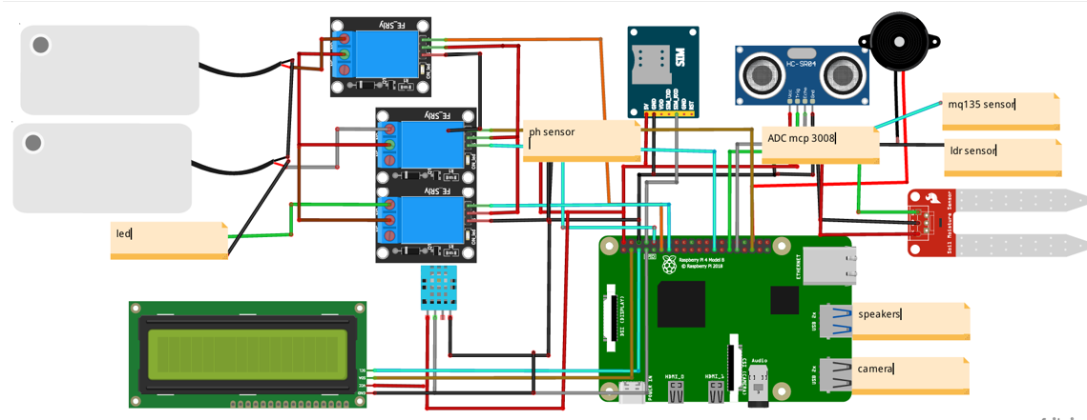

Figure 1: Circuit Diagram Illustrating Sensor Integration and Control Units

5. RESULTS:
AgroSense performs well in actual greenhouse conditions, according to experimental study. Important findings include:
- A reduction in manual irrigation labor of up to 80%.
- Precise identification of environmental and soil factors.
- Prompt notifications when dangerous gases (CO2, NH3) are present.
- Effective use of ultrasonic sensing for animal entry detection.
- Reliable performance because to low latency edge processing.
The technology demonstrated its robustness and utility by continuously maintaining greenhouse parameters within suggested thresholds.

6. ANALYSIS:
The practical issues with conventional greenhouse monitoring systems are addressed with AgroSense. Edge computing is perfect for remote farms because it guarantees quick decision-making and removes reliance on cloud infrastructure. While automated systems minimize human work, multi-sensor integration guarantees thorough monitoring. However, advancements like improved sensor calibration and predictive analytics can boost accuracy even more.

7. RECOMMENDATIONS:
- Use machine learning algorithms to forecast plant illnesses.
- For energy efficiency, include a solar power subsystem.

8. LIMITATIONS:
For optimal long-term measurement accuracy, it is crucial that sensors undergo regular calibration. Currently, the system has been designed to function effectively specifically within small to medium-sized greenhouse environments.

9. CONCLUSION / SUMMARY:
AgroSense shows how edge computing may be used to automate greenhouses. The system provides dependable, continuous monitoring and control by combining several sensors, automated actuators, and GSM alerting. It is appropriate for sustainable agricultural applications since it increases crop output while reducing labor and resource waste.

ACKNOWLEDGMENT:
The authors express their sincere gratitude to the Department of Artificial Intelligence and Data Science at SJC Institute of Technology for their invaluable support in providing laboratory resources and guidance throughout the course of the project.

REFERENCES
- Singh, A., Yadav, R., & Verma, S. (2018). Automated greenhouse monitoring.
- Rao, M., & Sharma, R. (2019). Intrusion detection using ultrasonic sensors.
- Manoj et al. (2023). Raspberry Pi greenhouse monitoring.
- Solase et al. (2023). Automated irrigation and worm detection.
- Preethi et al. (2018). IoT-based agriculture.
- Talasila et al. (2022). GSM greenhouse monitor

